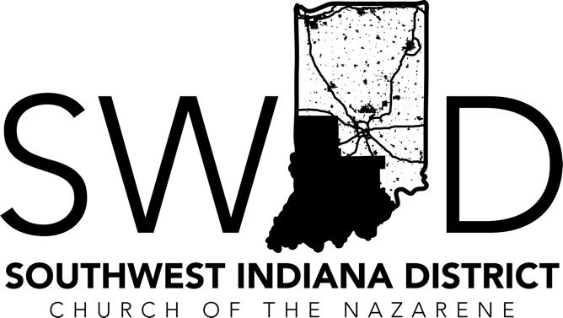
Board of Ministry Interview Questions
YEAR FOUR - SCOPE & SEQUENCE
 | Year One | Year Two | Year Three | Year Four
Articles of Faith | I-IV | V-VIII | IX-XII | XIII-XVI
Covenant of Christian Character | 21.1 (1-4) | 21.1 (5-7), 21.2 (1) | 21.2 (2-5) | 21.2 (6-8), 21.3
Covenant of Christian Conduct | The Christian  Life | Sanctity of Human  Life | Human Sexuality and  Marriage | Christian  Stewardship
Core Behaviors* | Win One | Disciple One | Start One | Reproduce One
Special Focus | District Culture | Global Church | Funding The Mission | Women in Ministry

It is necessary for a candidate to personally demonstrate competency in these four behaviors before interviewing for ordination. Wesley taught us that the Holy Spirit bears witness to us objectively and subjectively. Objectivity comes through Scripture and the study of the Word, where the Holy Spirit will bear witness in our spirit. Subjectivity is our personal experience outside of Scripture with the testimony of the Holy Spirit, who bears witness in our life. In other words, what is your answer from scripture, and how do you live?

- Articles of Faith
Article 13. We believe the Communion Supper instituted by our Lord and Savior Jesus Christ is a sacrament, proclaiming His life, sufferings, sacrificial death, resurrection, and the hope of His coming again. How would you explain the significance of practicing the sacrament of Holy Communion to your group or congregation? What things should we highlight, remember, and experience as we approach the Lord’s Table?

Article 14. We believe in the biblical doctrine of divine healing. How do your ministries’ prayer practices or teachings demonstrate that you believe in divine healing? Why is it important to help our people understand this concept?

Article 15. We believe that the Lord Jesus Christ will come again; that if we are abiding in Him, we shall be caught up with the risen saints to ever be with the Lord. From time to time, you will encounter a parishioner who says that they believe in Jesus and have given Him their life, but they’re not sure that they believe in things like the second coming. How would you explain the importance of this belief?

Article 16. We believe in future judgment in which every person shall appear before God to be judged according to his or her deeds in this life. Take us on two journeys. What happens to a believer who dies? What happens to a non-believer? Be detailed in your explanation.

- Covenant of Christian Character
21.2 Many people, even in the church, have a loose grip on honesty and bearing false witness. They allow room for “little white lies,” gossip, and exaggeration. What effect has this loose grip taken where you serve and why is this so important that we model and teach complete honesty, etc.?

21.2 How do you balance being relevant and non-judgmental with our congregations while still upholding the virtue of modesty?

The Covenant of Christian Character states that we should avoid music, literature, and entertainments that dishonor God. What are the advantages of abiding by this?

Why is it important that people be active church-goers and that their behavior patterns reflect COTN doctrine?

- Covenant of Christian Conduct
D. Christian Stewardship
32.1 We believe that God is the Owner of all persons and all things. We, therefore, are His stewards (managers)of both life and possessions. How does this belief set up a proper understanding of God’s command to tithe? What implications does the steward/manager concept have beyond financial giving?

Explain how your personal stewardship practices align with Scripture and Manual paragraphs 32- 32.5?

- Special Focus
How would you defend or how have you defended the COTN’s position on women in ministry?

Why is it important that both genders—and beyond that, all races, ethnicities, and ages—be included at the leadership table?

* All quotes from the MANUAL 2017 - 2021

