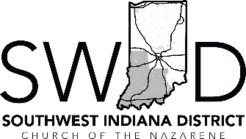 | 2024 SWID Ministry  Candidate Workshop

CHURCH BOARD RECOMMENDATION

CHURCH NAME: ______________________________________

We, the church board of ______________________ Church of the Nazarene, support the following licensed
CHURCH NAME
ministers from our church to attend the upcoming Ministerial Candidates Workshop as part of their continuing journey towards ordained ministry in the Church of the Nazarene:

Licensed Minister Name(s): _________________________________________________________
We acknowledge that we are recommended to support our licensed ministers participating in this workshop by sponsoring $80 of the licensed minister’s $160 fee.

Pastor or *Church Board Secretary Name: ___________________________________

Pastor or *Church Board Secretary Signature:

Date: ___________________________________

*The Church Board Secretary’s signature is required if the Pastor is a Licensed Minister / Candidate.

*** Please provide a copy of this recommendation to each of your licensed ministers
to be included with their Ministry Candidate Workshop applications that are required to be scanned and submitted to Nathan Rogers (nrogers@swidnazarene.org) by December 15, 2023.
SWID Ministerial Candidate Workshop
Date: January 26-27, 2024
Location: Country Lake Christian Retreat 815 Country Lake Rd. Underwood, IN. 47177
Cost: $160 per person (1/2 to be paid by church). $80 for spouse.

